Work/Life Harmony
Notes handout · Human Centered Lab · julesmorrisphd.com
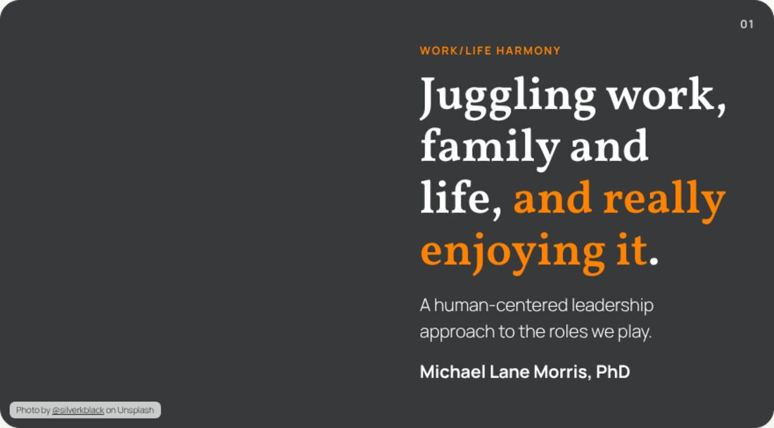 | Notes  ______________________________________________  ______________________________________________  ______________________________________________  ______________________________________________  ______________________________________________  ______________________________________________  ______________________________________________
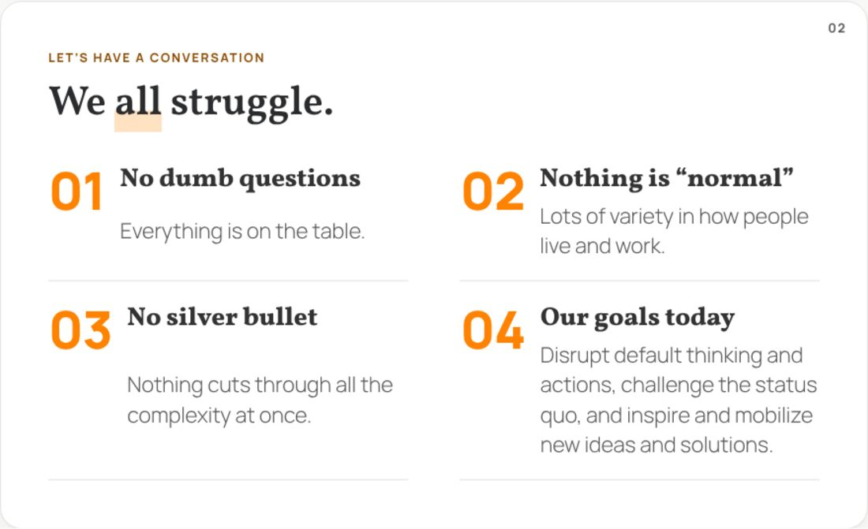 | Notes  ______________________________________________  ______________________________________________  ______________________________________________  ______________________________________________  ______________________________________________  ______________________________________________  ______________________________________________
 | Notes  ______________________________________________  ______________________________________________  ______________________________________________  ______________________________________________  ______________________________________________  ______________________________________________  ______________________________________________

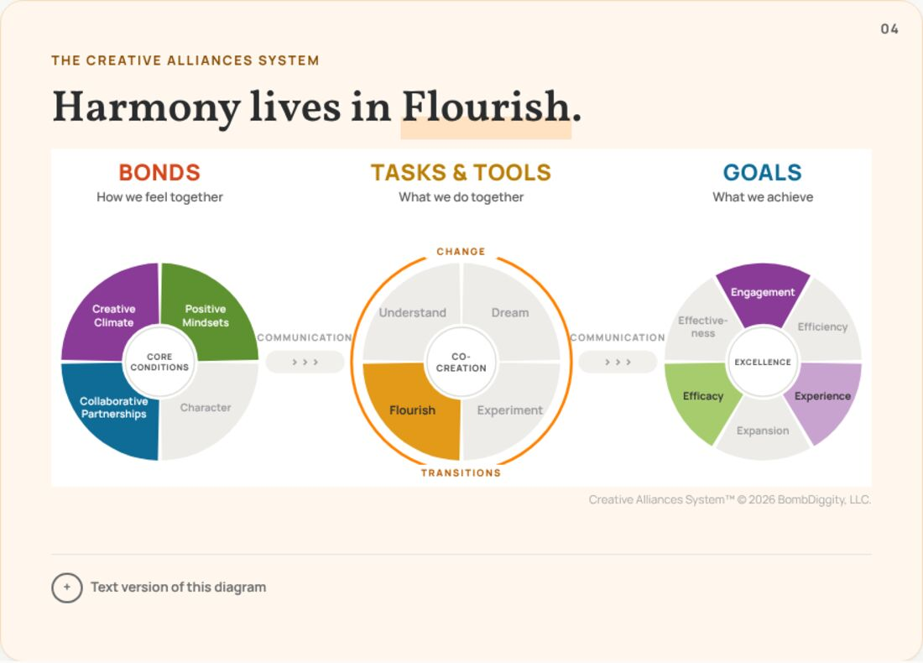 | Notes  ______________________________________________  ______________________________________________  ______________________________________________  ______________________________________________  ______________________________________________  ______________________________________________  ______________________________________________
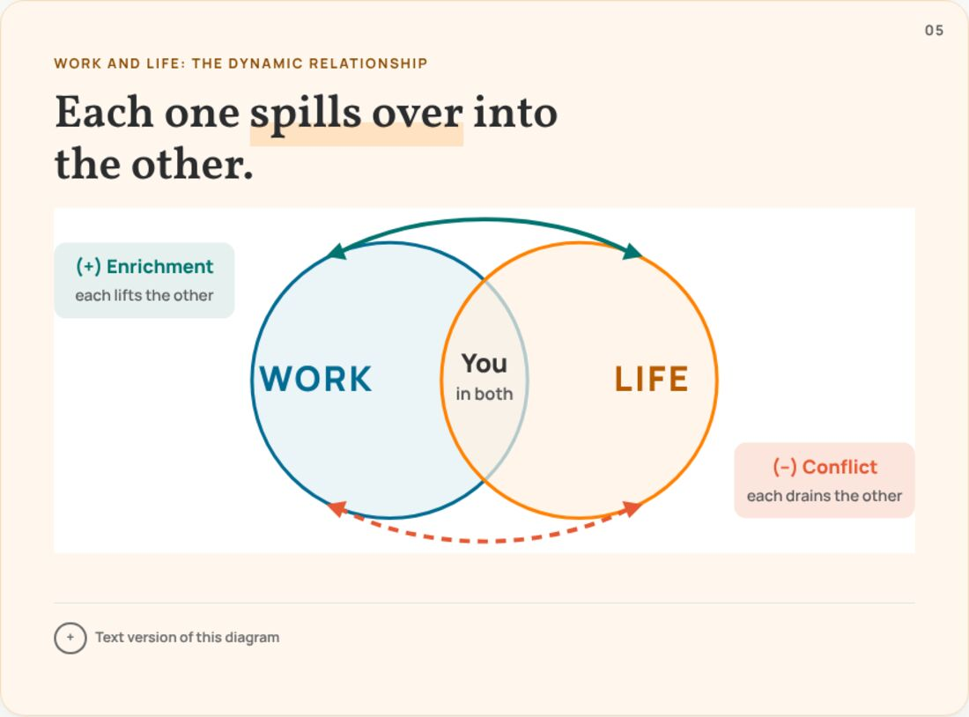 | Notes  ______________________________________________  ______________________________________________  ______________________________________________  ______________________________________________  ______________________________________________  ______________________________________________  ______________________________________________
 | Notes  ______________________________________________  ______________________________________________  ______________________________________________  ______________________________________________  ______________________________________________  ______________________________________________  ______________________________________________

 | Notes  ______________________________________________  ______________________________________________  ______________________________________________  ______________________________________________  ______________________________________________  ______________________________________________  ______________________________________________
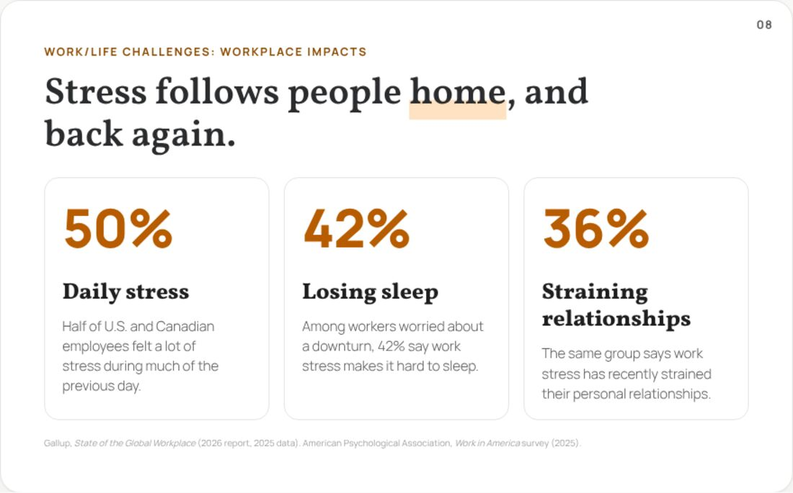 | Notes  ______________________________________________  ______________________________________________  ______________________________________________  ______________________________________________  ______________________________________________  ______________________________________________  ______________________________________________
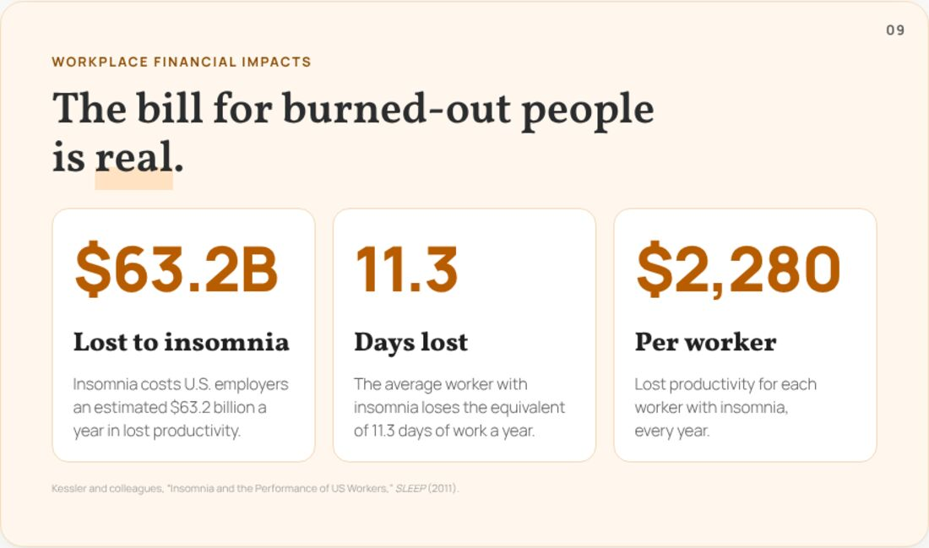 | Notes  ______________________________________________  ______________________________________________  ______________________________________________  ______________________________________________  ______________________________________________  ______________________________________________  ______________________________________________

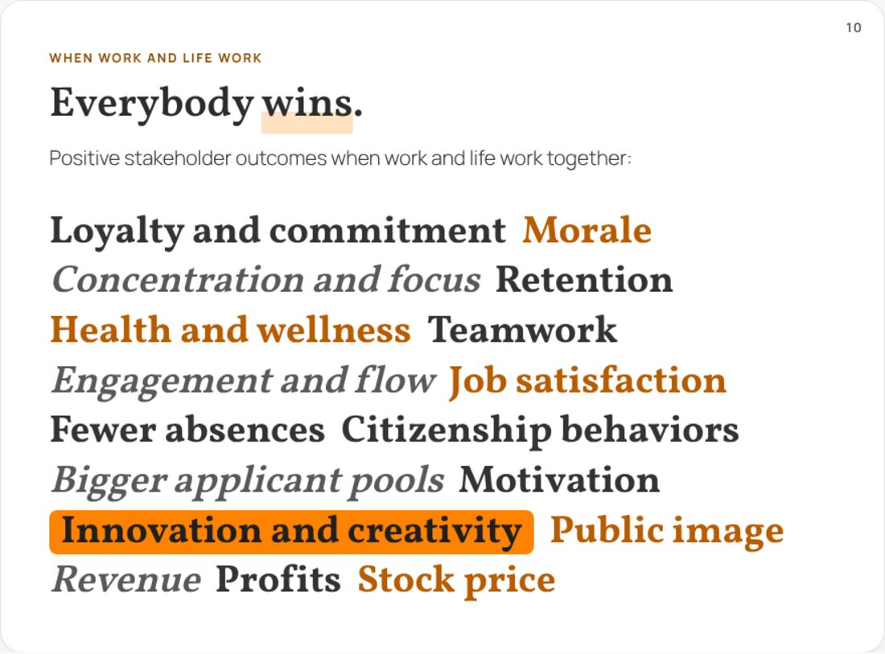 | Notes  ______________________________________________  ______________________________________________  ______________________________________________  ______________________________________________  ______________________________________________  ______________________________________________  ______________________________________________
 | Notes  ______________________________________________  ______________________________________________  ______________________________________________  ______________________________________________  ______________________________________________  ______________________________________________  ______________________________________________
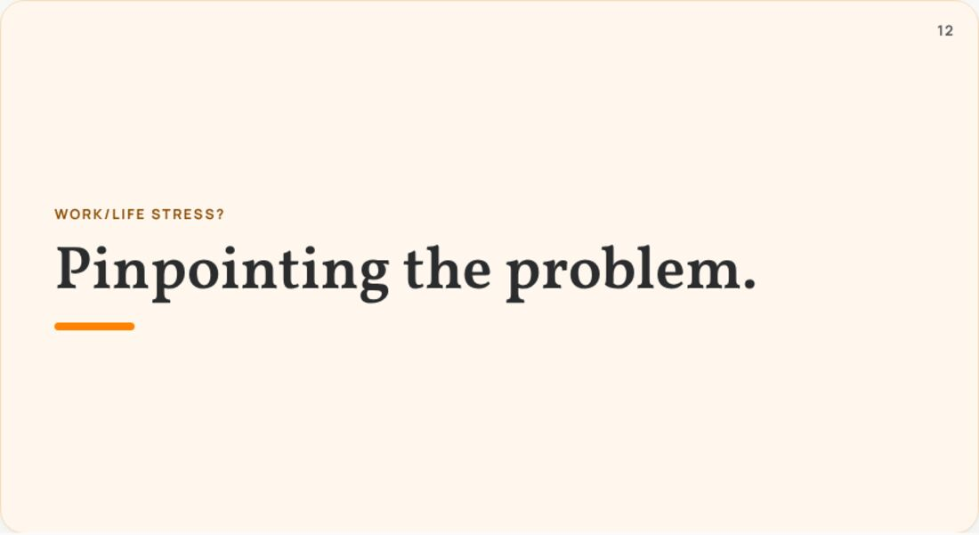 | Notes  ______________________________________________  ______________________________________________  ______________________________________________  ______________________________________________  ______________________________________________  ______________________________________________  ______________________________________________

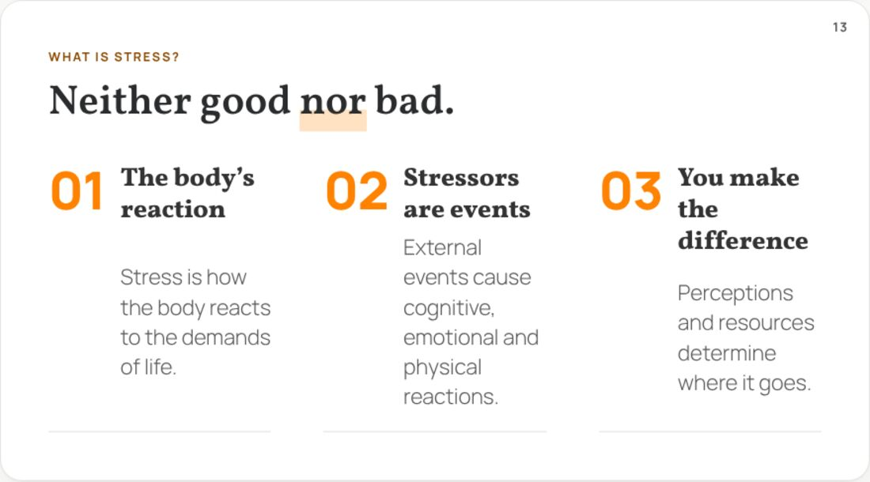 | Notes  ______________________________________________  ______________________________________________  ______________________________________________  ______________________________________________  ______________________________________________  ______________________________________________  ______________________________________________
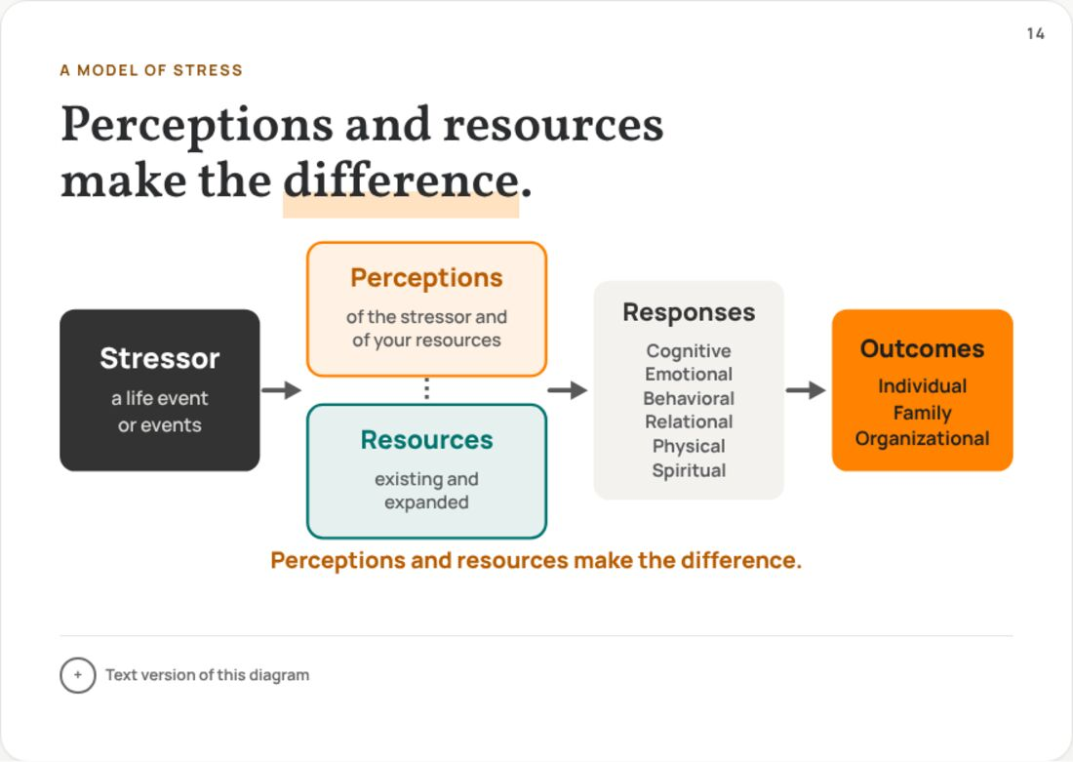 | Notes  ______________________________________________  ______________________________________________  ______________________________________________  ______________________________________________  ______________________________________________  ______________________________________________  ______________________________________________
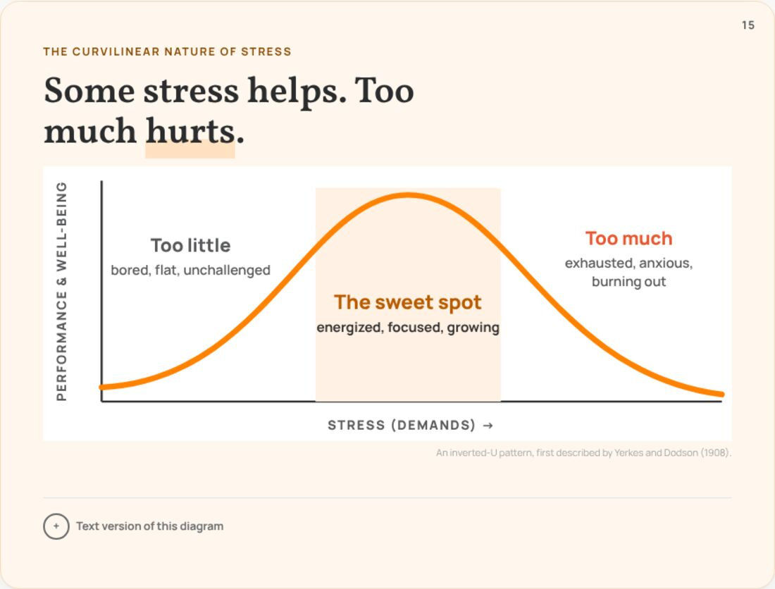 | Notes  ______________________________________________  ______________________________________________  ______________________________________________  ______________________________________________  ______________________________________________  ______________________________________________  ______________________________________________

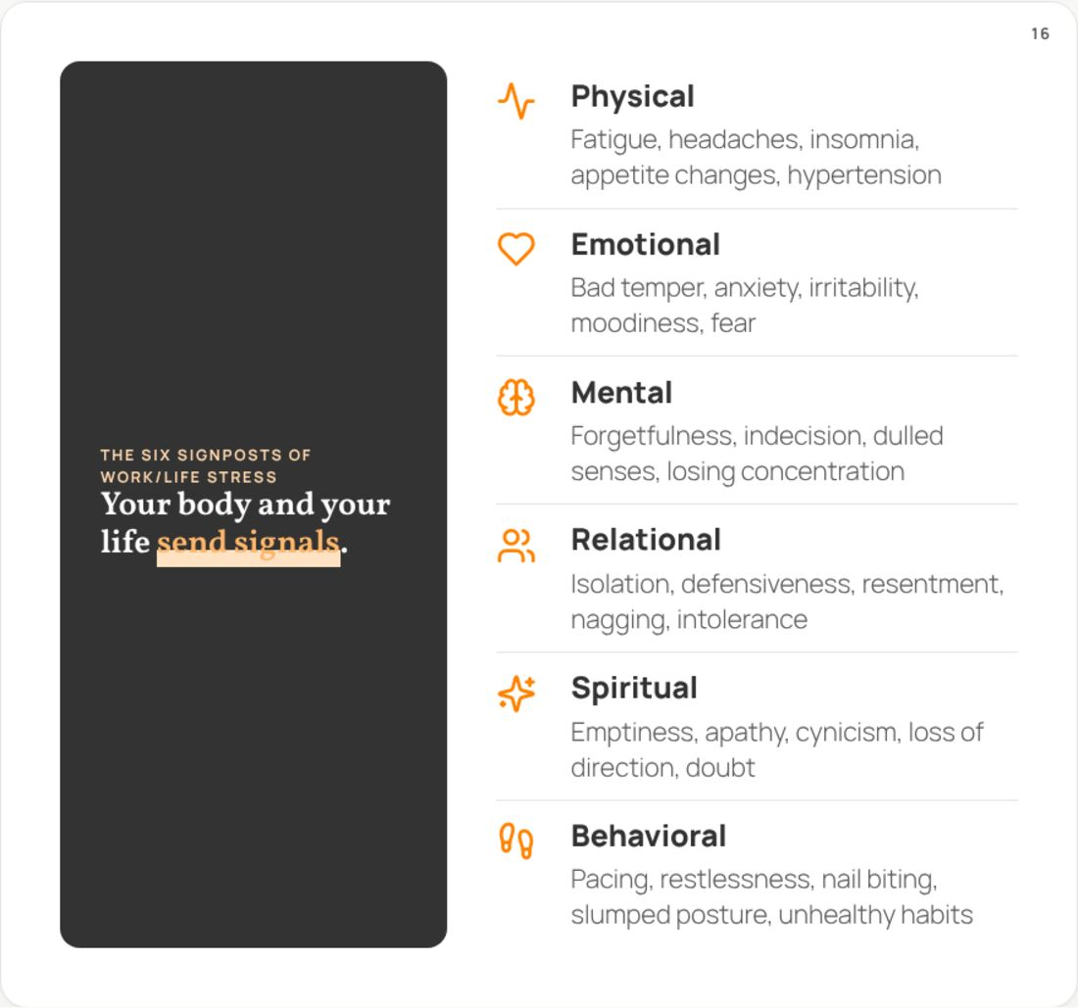 | Notes  ______________________________________________  ______________________________________________  ______________________________________________  ______________________________________________  ______________________________________________  ______________________________________________  ______________________________________________
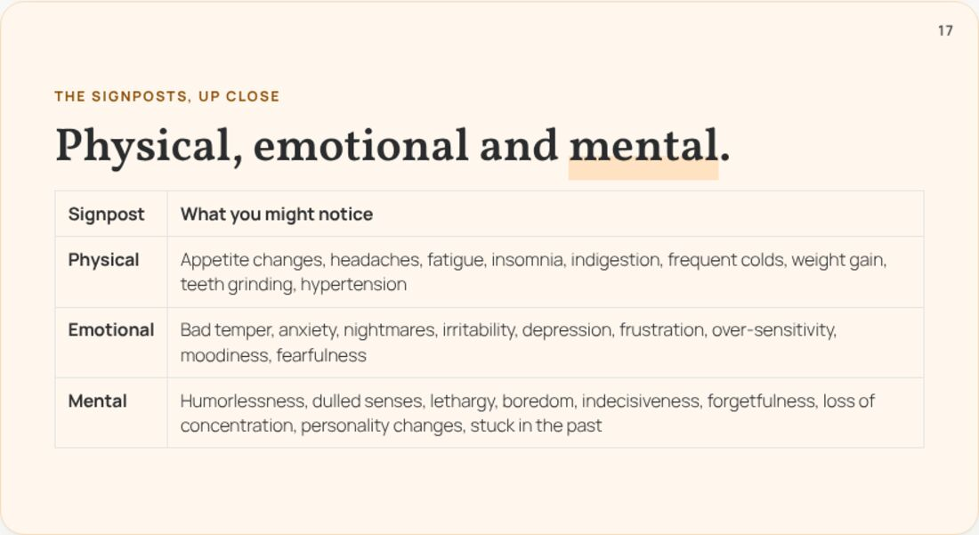 | Notes  ______________________________________________  ______________________________________________  ______________________________________________  ______________________________________________  ______________________________________________  ______________________________________________  ______________________________________________
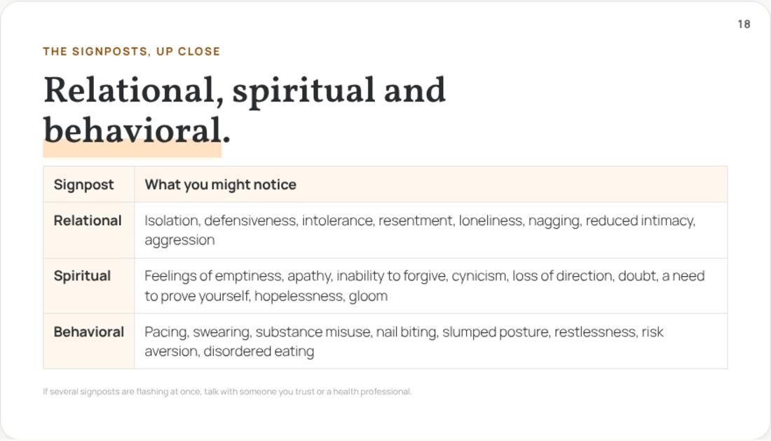 | Notes  ______________________________________________  ______________________________________________  ______________________________________________  ______________________________________________  ______________________________________________  ______________________________________________  ______________________________________________

 | Notes  ______________________________________________  ______________________________________________  ______________________________________________  ______________________________________________  ______________________________________________  ______________________________________________  ______________________________________________
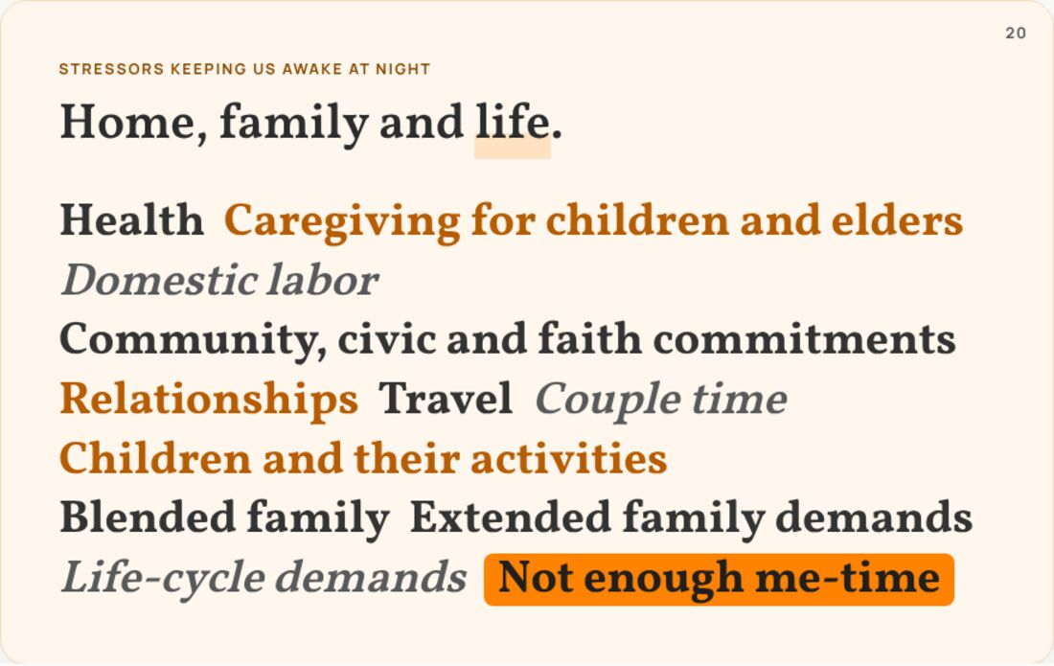 | Notes  ______________________________________________  ______________________________________________  ______________________________________________  ______________________________________________  ______________________________________________  ______________________________________________  ______________________________________________
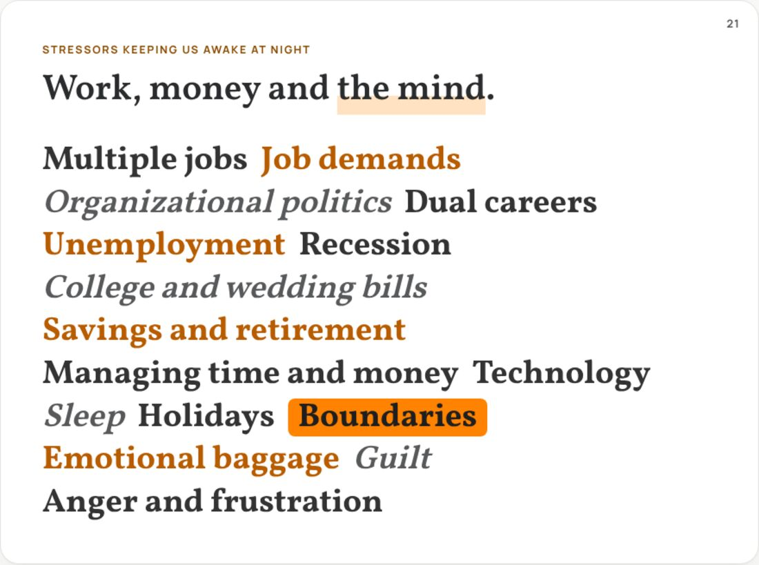 | Notes  ______________________________________________  ______________________________________________  ______________________________________________  ______________________________________________  ______________________________________________  ______________________________________________  ______________________________________________

 | Notes  ______________________________________________  ______________________________________________  ______________________________________________  ______________________________________________  ______________________________________________  ______________________________________________  ______________________________________________
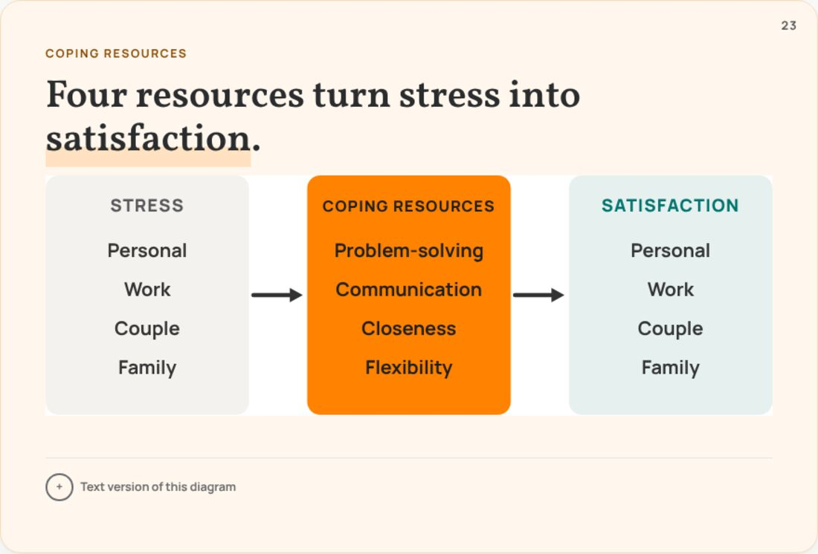 | Notes  ______________________________________________  ______________________________________________  ______________________________________________  ______________________________________________  ______________________________________________  ______________________________________________  ______________________________________________
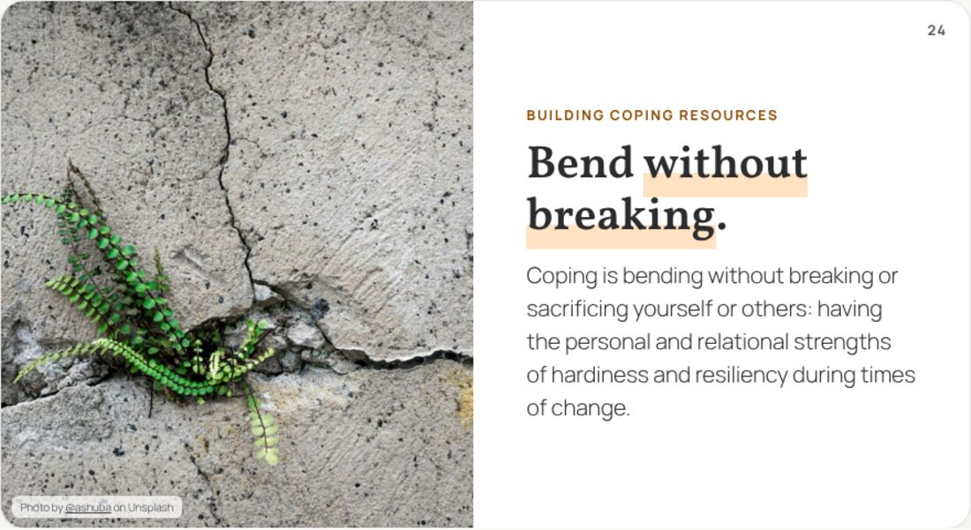 | Notes  ______________________________________________  ______________________________________________  ______________________________________________  ______________________________________________  ______________________________________________  ______________________________________________  ______________________________________________

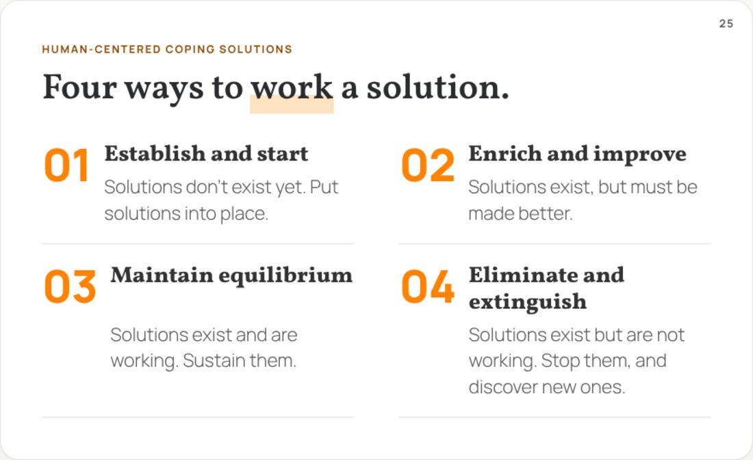 | Notes  ______________________________________________  ______________________________________________  ______________________________________________  ______________________________________________  ______________________________________________  ______________________________________________  ______________________________________________
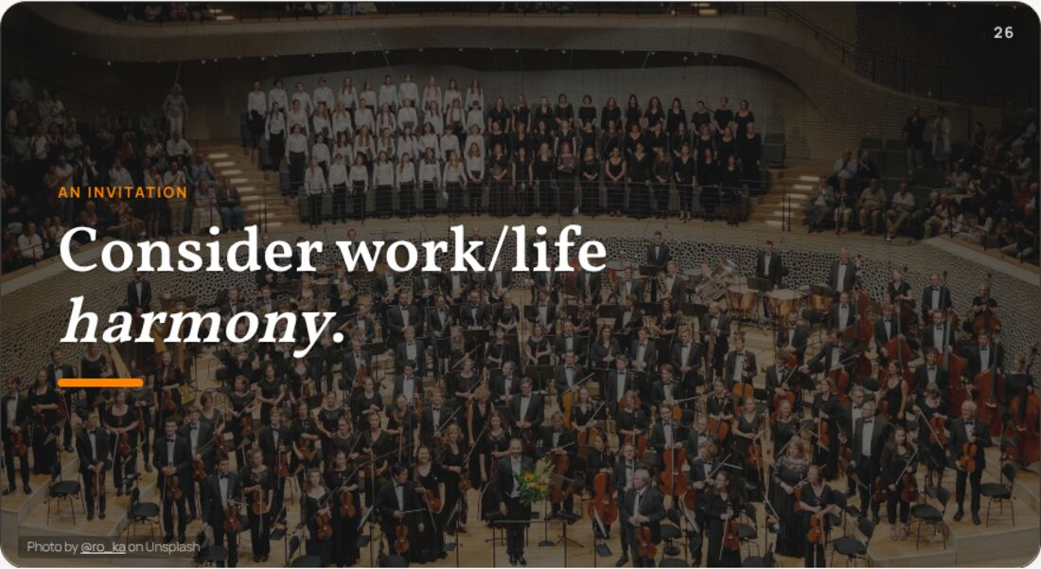 | Notes  ______________________________________________  ______________________________________________  ______________________________________________  ______________________________________________  ______________________________________________  ______________________________________________  ______________________________________________
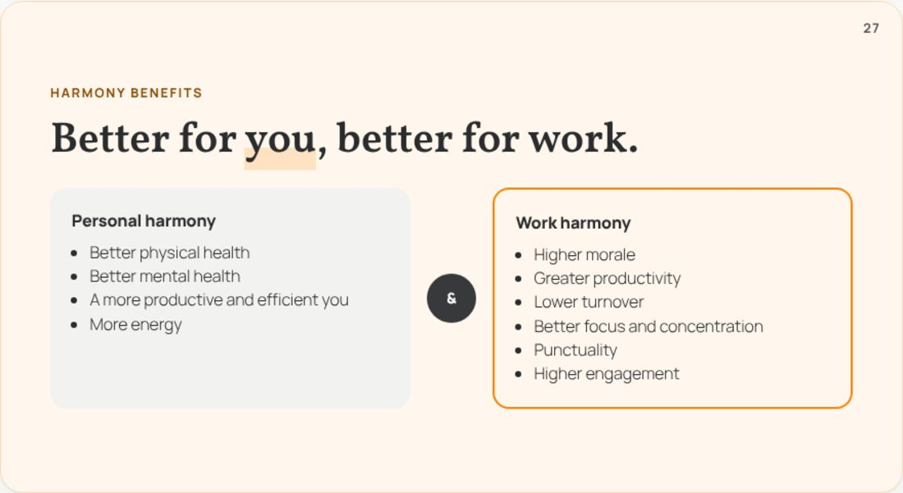 | Notes  ______________________________________________  ______________________________________________  ______________________________________________  ______________________________________________  ______________________________________________  ______________________________________________  ______________________________________________

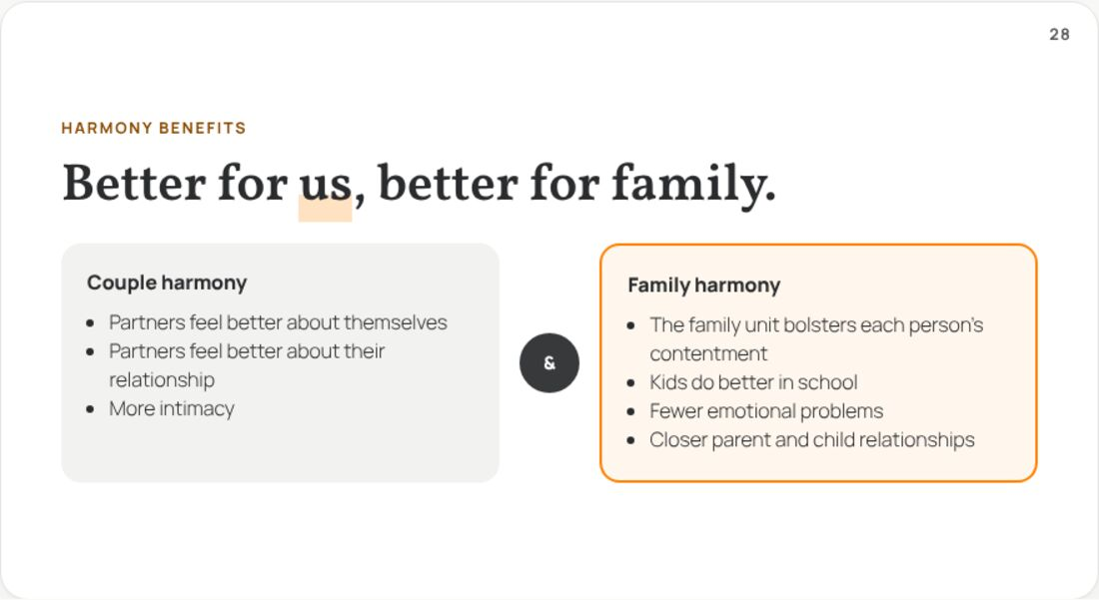 | Notes  ______________________________________________  ______________________________________________  ______________________________________________  ______________________________________________  ______________________________________________  ______________________________________________  ______________________________________________
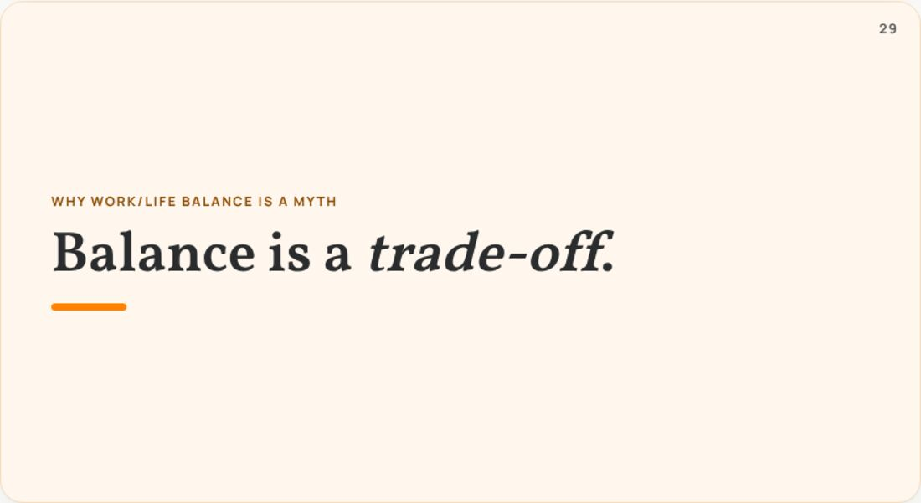 | Notes  ______________________________________________  ______________________________________________  ______________________________________________  ______________________________________________  ______________________________________________  ______________________________________________  ______________________________________________
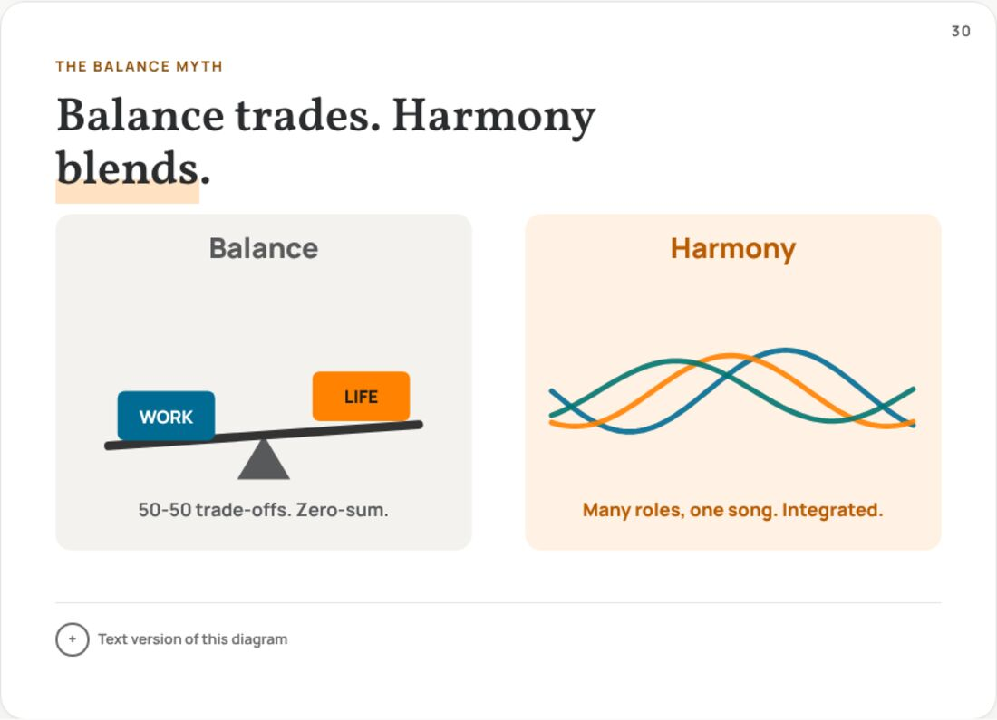 | Notes  ______________________________________________  ______________________________________________  ______________________________________________  ______________________________________________  ______________________________________________  ______________________________________________  ______________________________________________

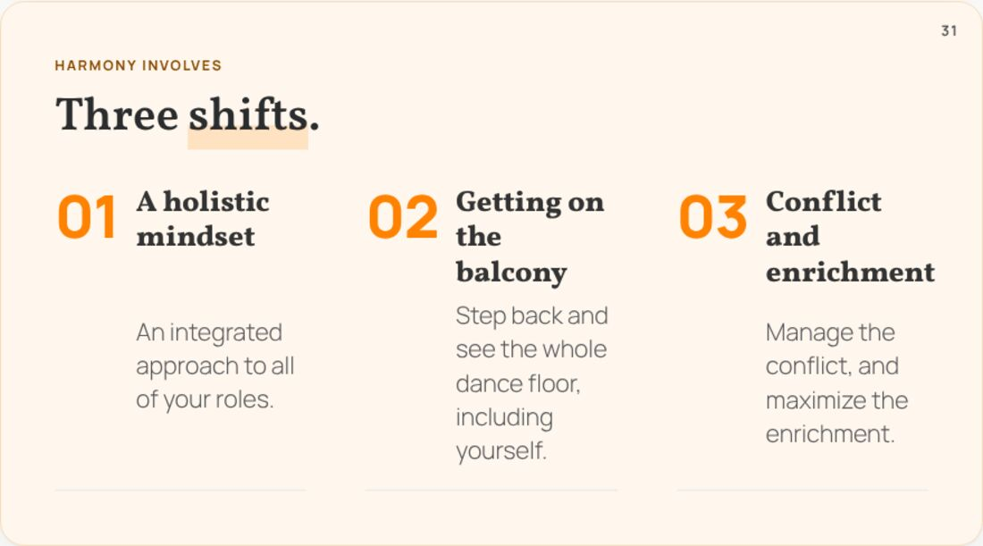 | Notes  ______________________________________________  ______________________________________________  ______________________________________________  ______________________________________________  ______________________________________________  ______________________________________________  ______________________________________________
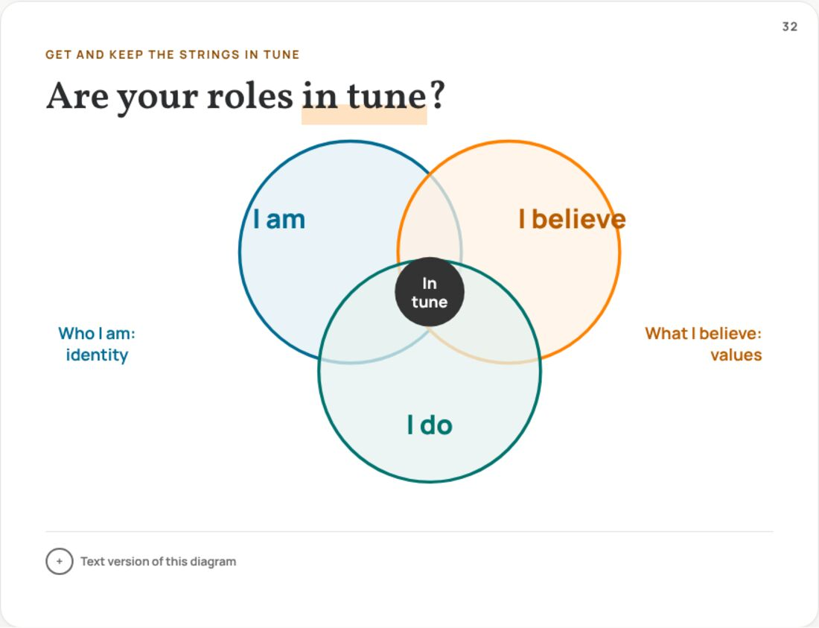 | Notes  ______________________________________________  ______________________________________________  ______________________________________________  ______________________________________________  ______________________________________________  ______________________________________________  ______________________________________________
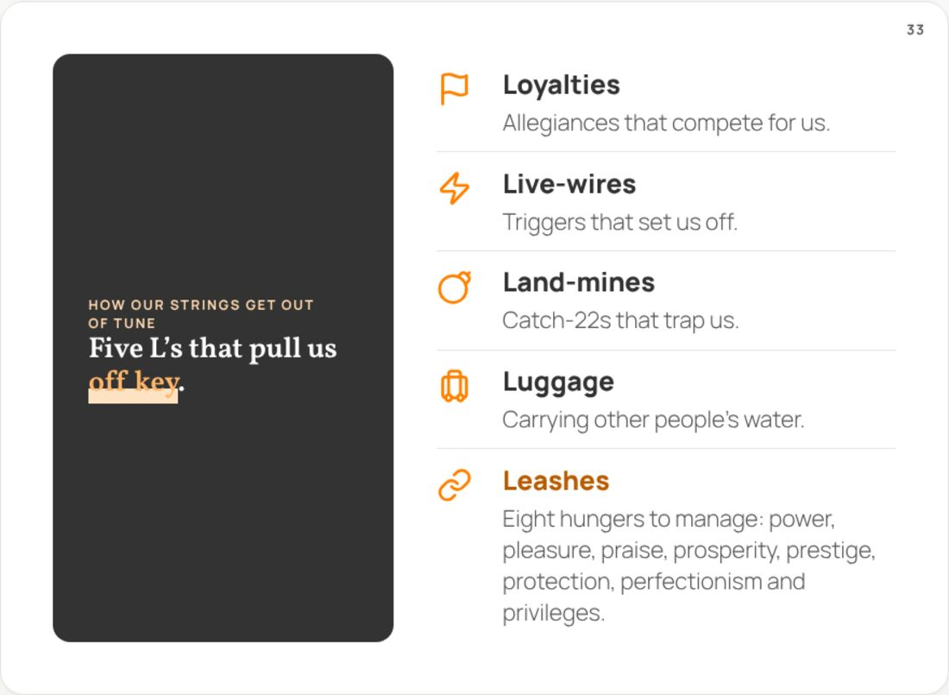 | Notes  ______________________________________________  ______________________________________________  ______________________________________________  ______________________________________________  ______________________________________________  ______________________________________________  ______________________________________________

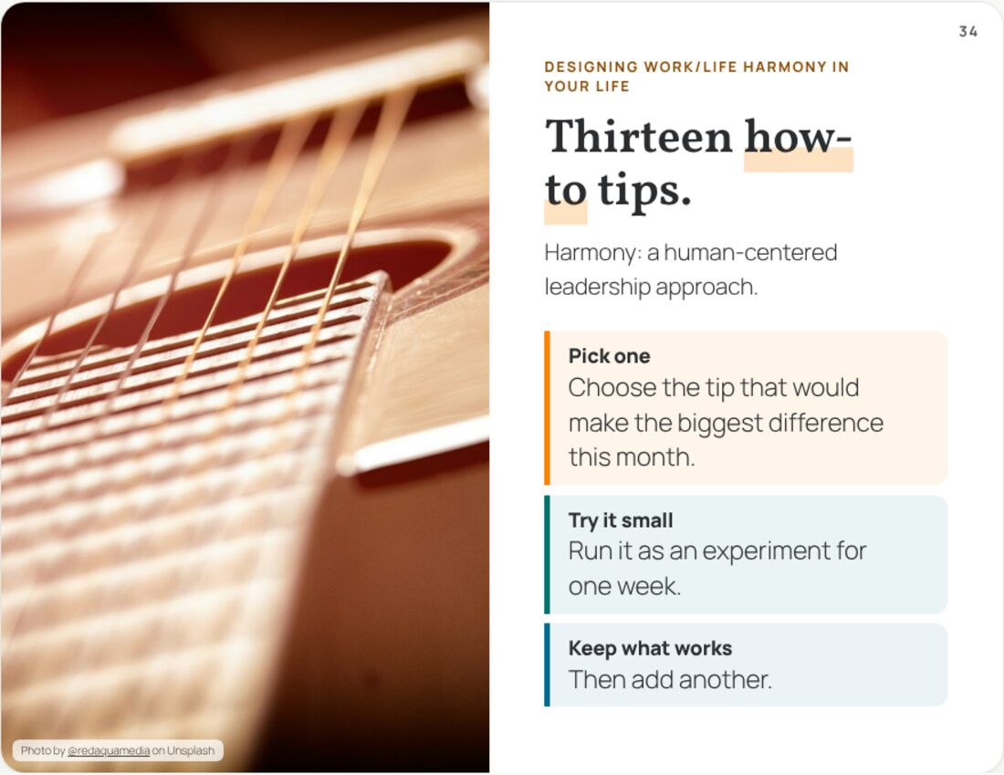 | Notes  ______________________________________________  ______________________________________________  ______________________________________________  ______________________________________________  ______________________________________________  ______________________________________________  ______________________________________________
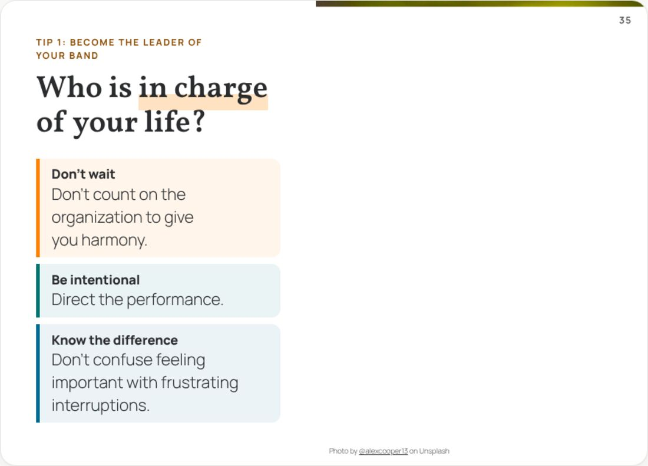 | Notes  ______________________________________________  ______________________________________________  ______________________________________________  ______________________________________________  ______________________________________________  ______________________________________________  ______________________________________________
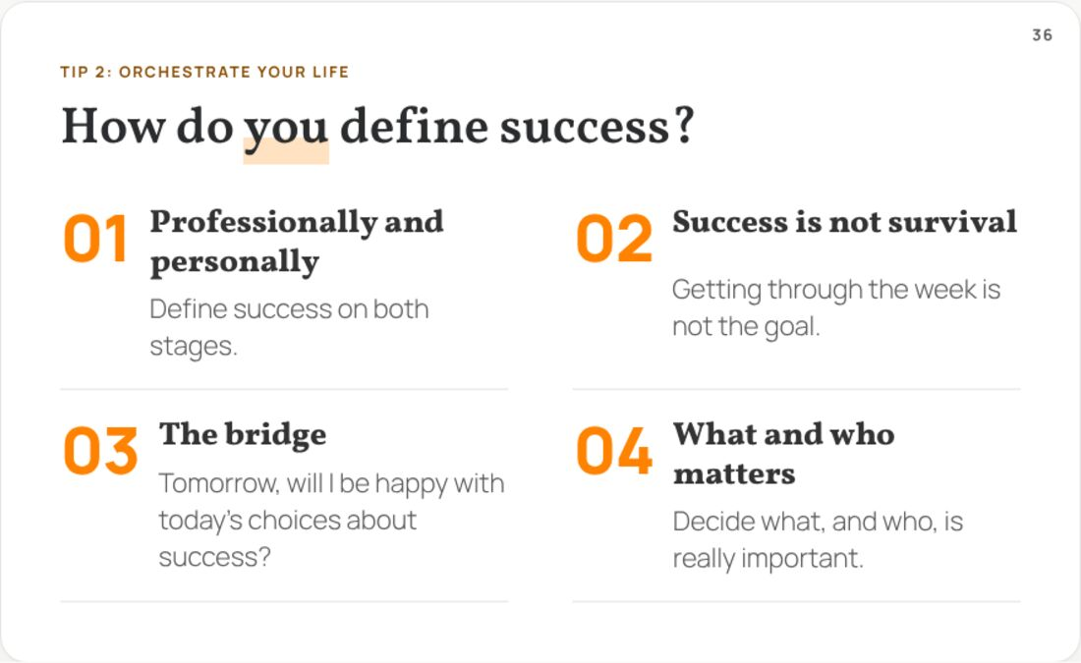 | Notes  ______________________________________________  ______________________________________________  ______________________________________________  ______________________________________________  ______________________________________________  ______________________________________________  ______________________________________________

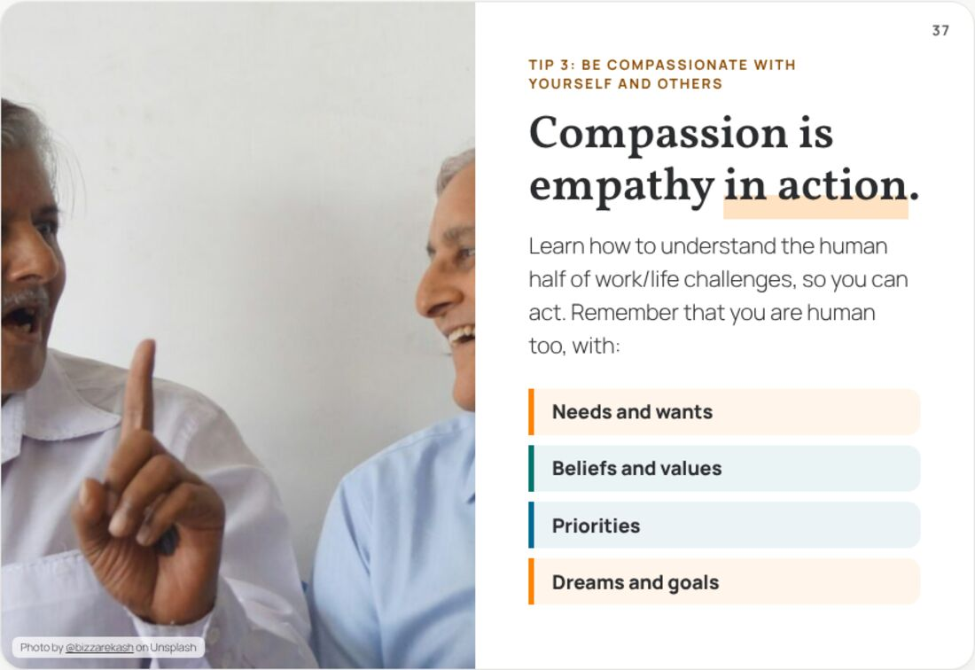 | Notes  ______________________________________________  ______________________________________________  ______________________________________________  ______________________________________________  ______________________________________________  ______________________________________________  ______________________________________________
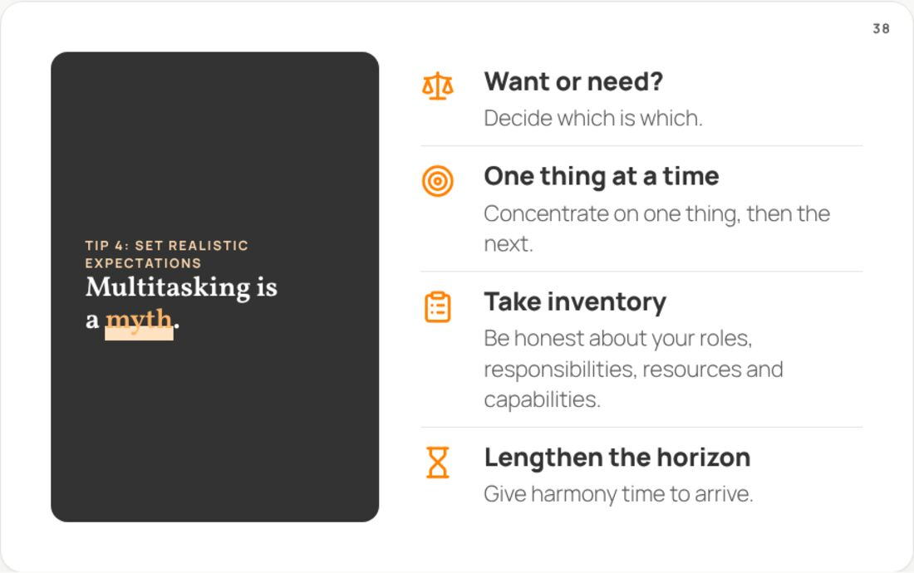 | Notes  ______________________________________________  ______________________________________________  ______________________________________________  ______________________________________________  ______________________________________________  ______________________________________________  ______________________________________________
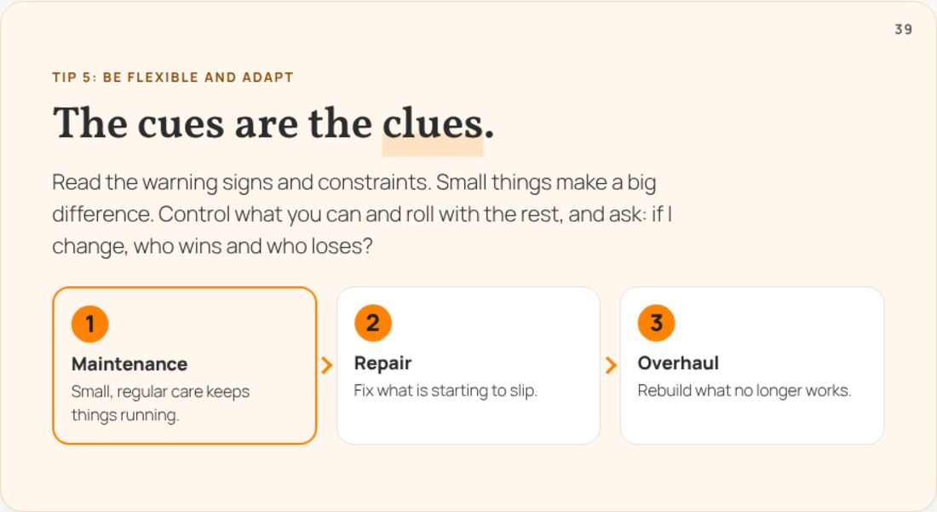 | Notes  ______________________________________________  ______________________________________________  ______________________________________________  ______________________________________________  ______________________________________________  ______________________________________________  ______________________________________________

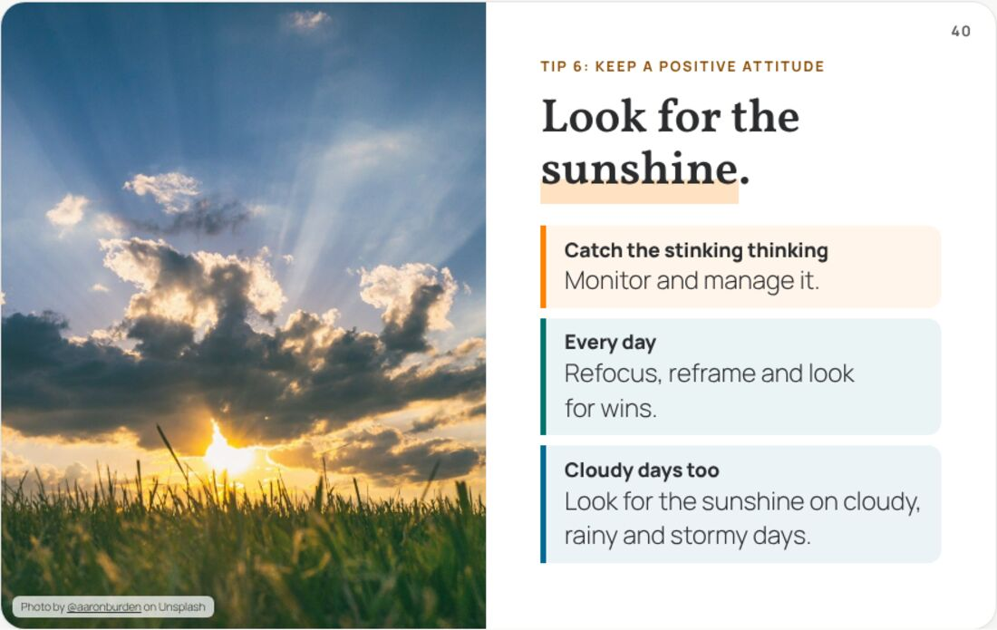 | Notes  ______________________________________________  ______________________________________________  ______________________________________________  ______________________________________________  ______________________________________________  ______________________________________________  ______________________________________________
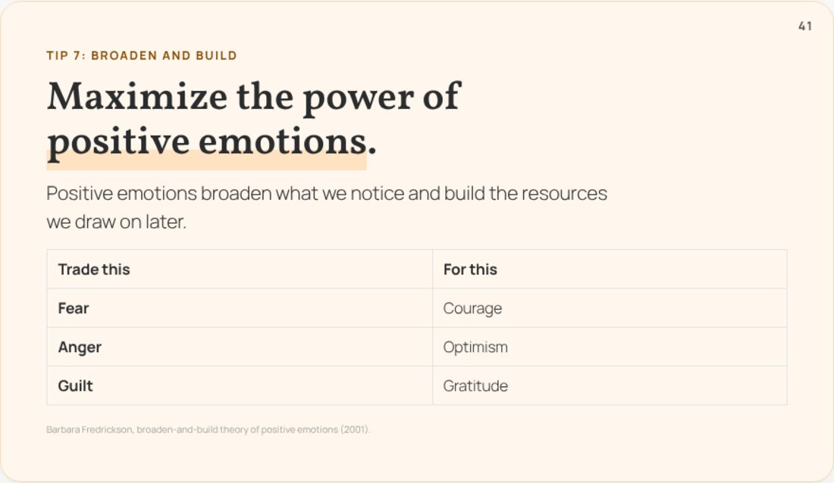 | Notes  ______________________________________________  ______________________________________________  ______________________________________________  ______________________________________________  ______________________________________________  ______________________________________________  ______________________________________________
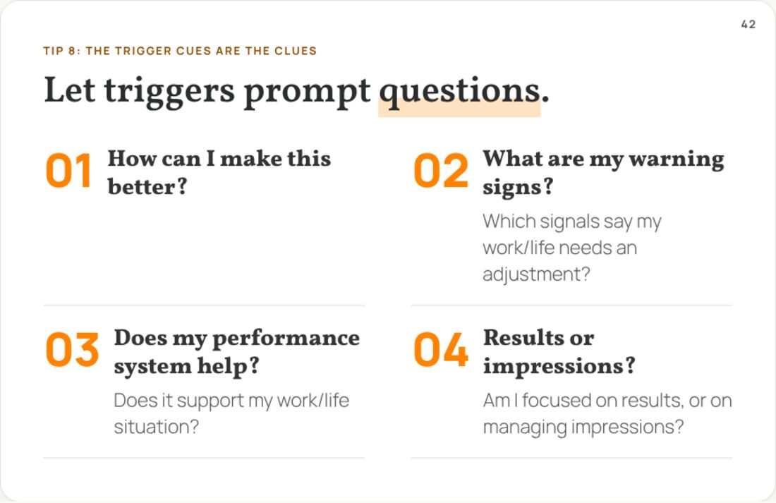 | Notes  ______________________________________________  ______________________________________________  ______________________________________________  ______________________________________________  ______________________________________________  ______________________________________________  ______________________________________________

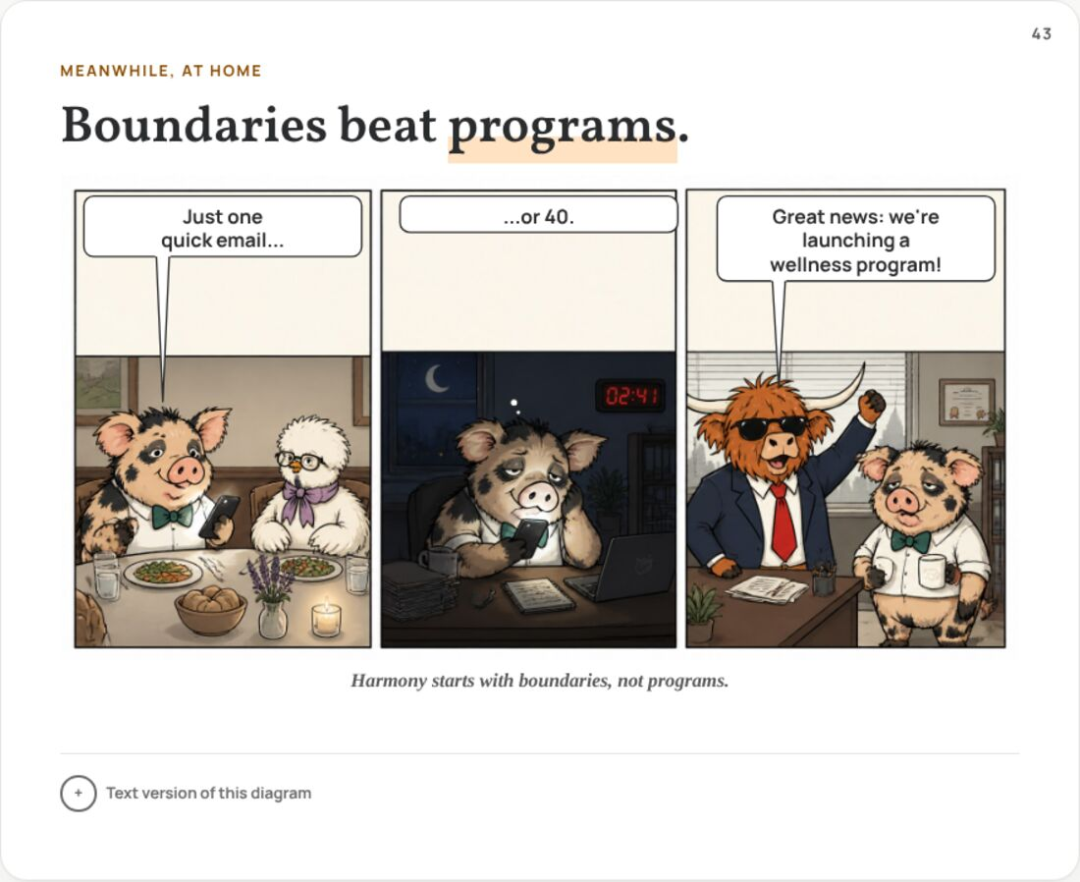 | Notes  ______________________________________________  ______________________________________________  ______________________________________________  ______________________________________________  ______________________________________________  ______________________________________________  ______________________________________________
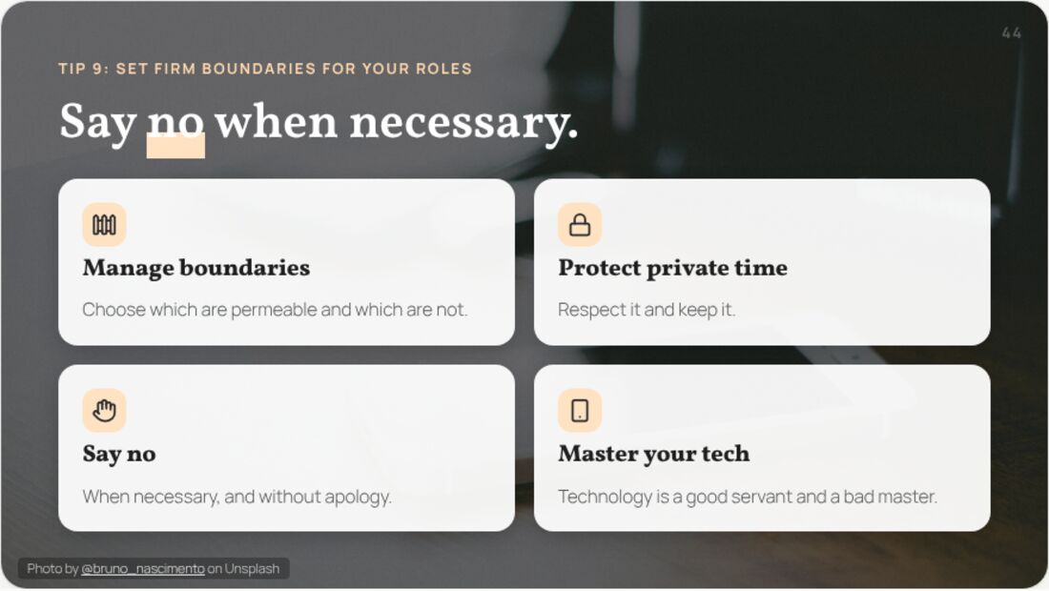 | Notes  ______________________________________________  ______________________________________________  ______________________________________________  ______________________________________________  ______________________________________________  ______________________________________________  ______________________________________________
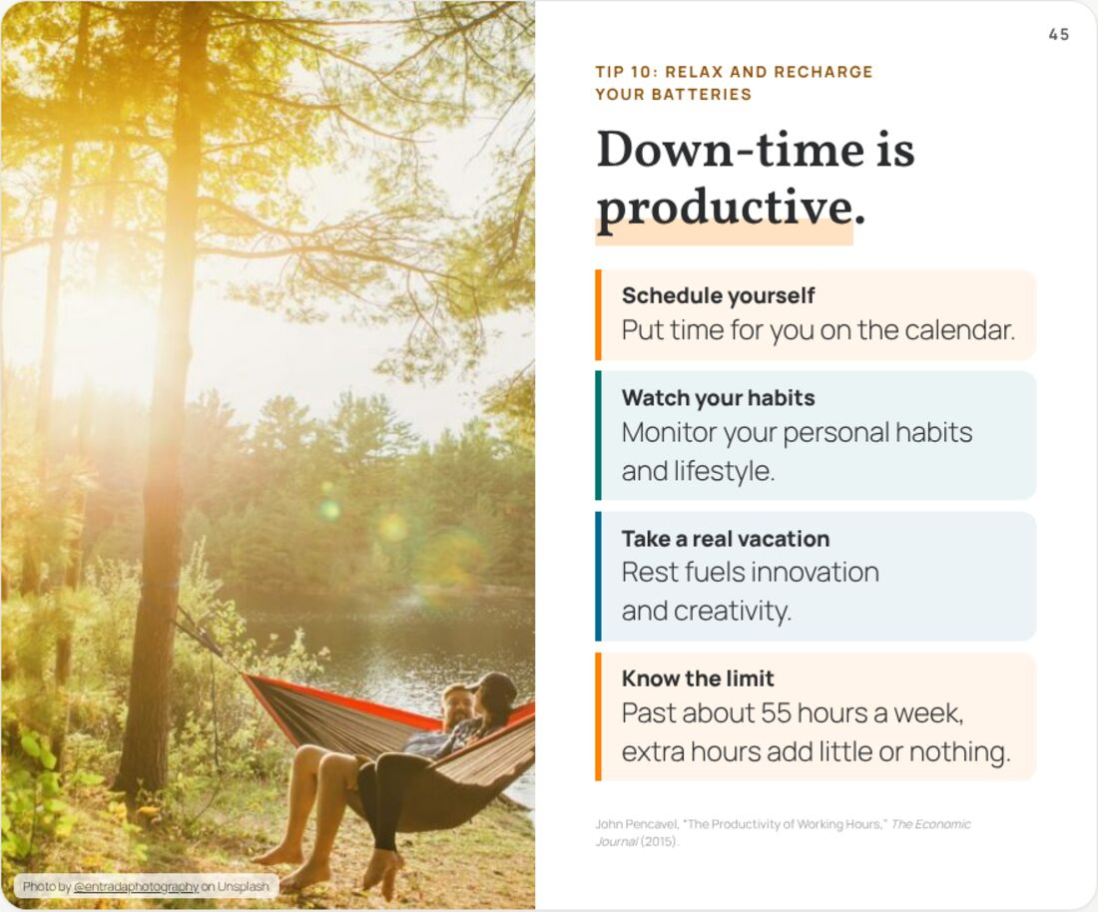 | Notes  ______________________________________________  ______________________________________________  ______________________________________________  ______________________________________________  ______________________________________________  ______________________________________________  ______________________________________________

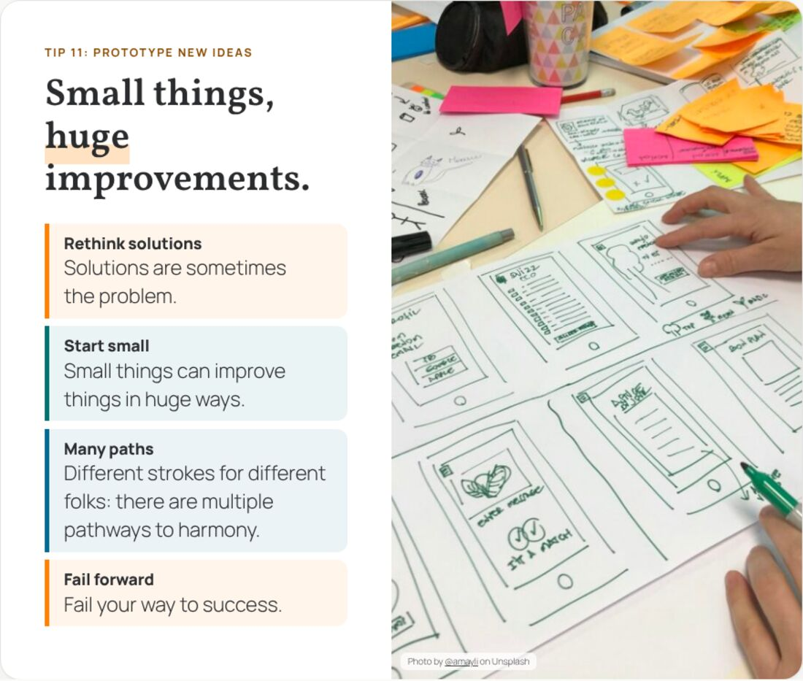 | Notes  ______________________________________________  ______________________________________________  ______________________________________________  ______________________________________________  ______________________________________________  ______________________________________________  ______________________________________________
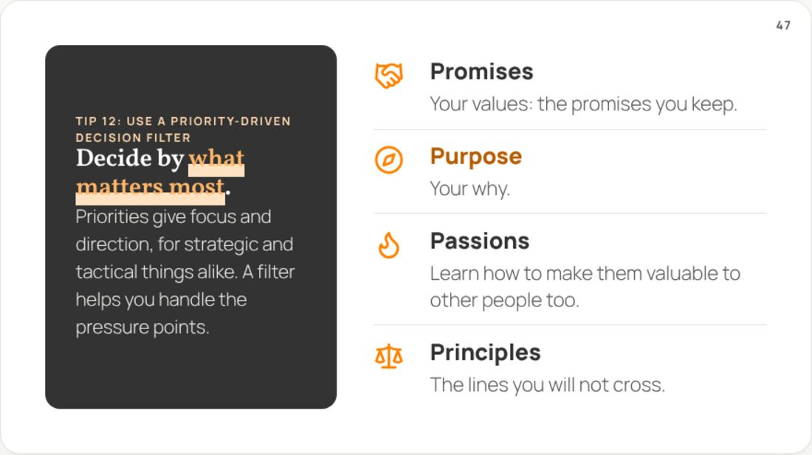 | Notes  ______________________________________________  ______________________________________________  ______________________________________________  ______________________________________________  ______________________________________________  ______________________________________________  ______________________________________________
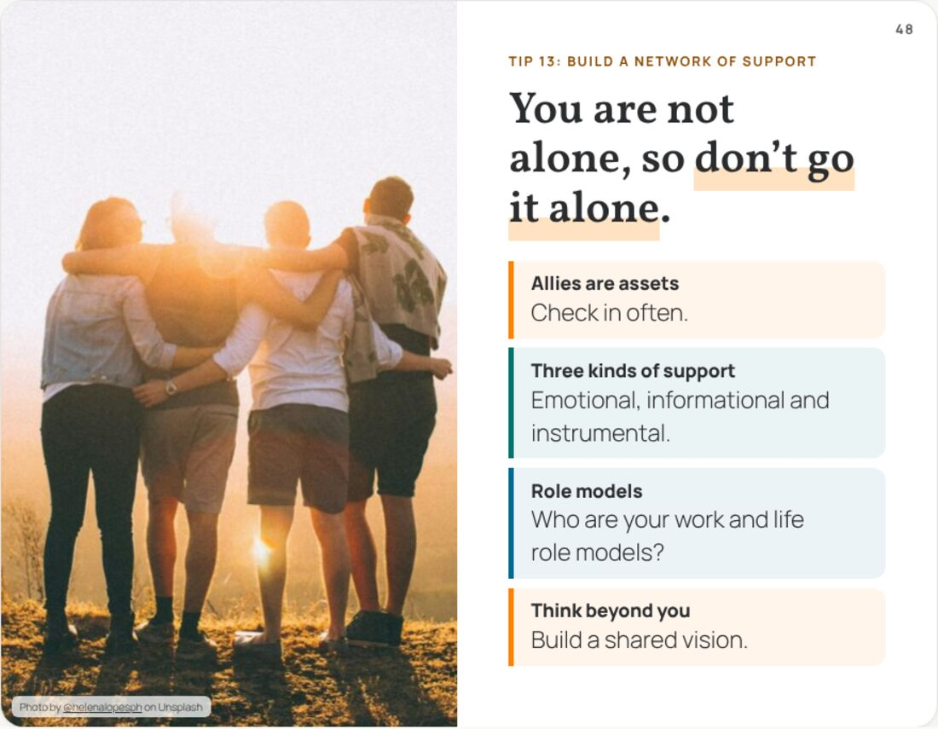 | Notes  ______________________________________________  ______________________________________________  ______________________________________________  ______________________________________________  ______________________________________________  ______________________________________________  ______________________________________________

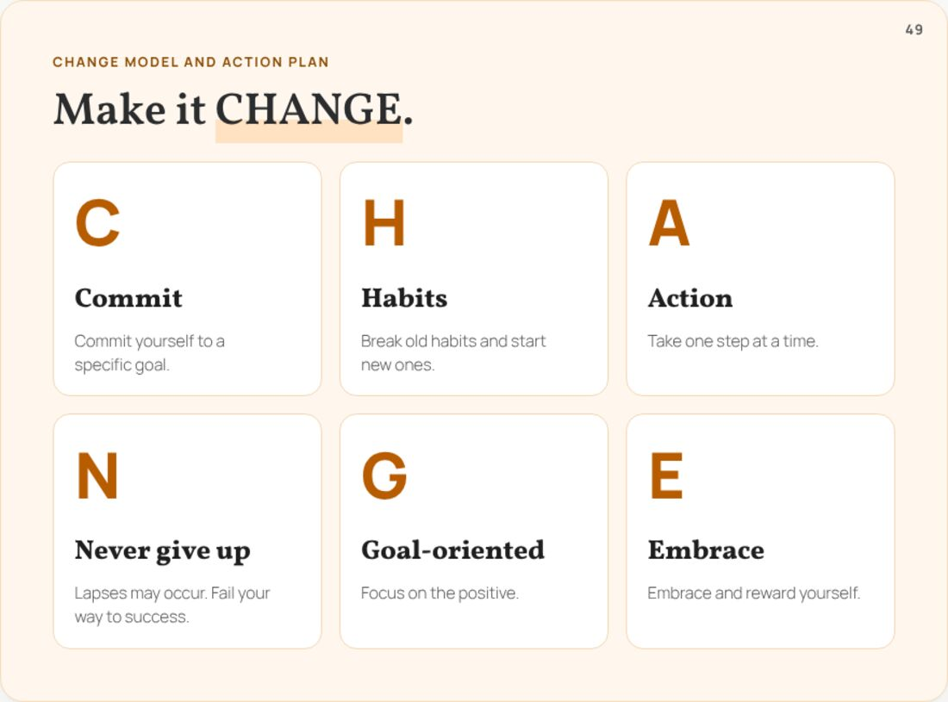 | Notes  ______________________________________________  ______________________________________________  ______________________________________________  ______________________________________________  ______________________________________________  ______________________________________________  ______________________________________________
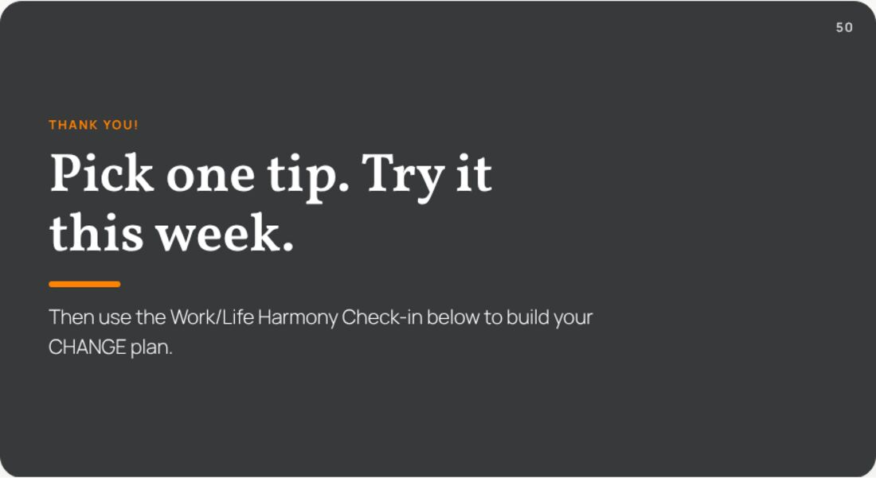 | Notes  ______________________________________________  ______________________________________________  ______________________________________________  ______________________________________________  ______________________________________________  ______________________________________________  ______________________________________________

